Computer Architecture

CPU simulator-Part 2

1. Introduction

In Part 1, we programmed a CPU simulator that can execute few instructions (STR, LDR). In Part 2, we realized all the Load/Store, Transfer, Arithmetic and Logical instructions. We also designed the cache and memory banking. At the same time, we revised the UI to make it more utility and friendly. Our simulator has three kinds of working mode, which are “Run”,“debug” and “SingleStep”. For “Run”and “Debug”mode, the CPU runs all the instructions stored in memory. However, there are differences between these two modes. Besides running all the instructions, CPU running in “Debug mode” prints the log of every instruction. When running on “SingleStep” mode, the CPU execute only one instruction.

1. Program design

Our source code consists of eight packages, and each of them realizes different function:

|  |  |
| --- | --- |
| Name of Packages | Function |
| edu.gwu.computerarchitecture.alu | Realize Arithmetic Logical Unit |
| edu.gwu.computerarchitecture.cache | Realize cache operation |
| edu.gwu.computerarchitecture.cpu | Realize CPU operation |
| edu.gwu.computerarchitecture.entity | Define register and memory |
| edu.gwu.computerarchitecture.main | Entrance of the entire program |
| edu.gwu.computerarchitecture.operation | Define instructions, and Realize fetch, decode, writeback |
| edu.gwu.computerarchitecture.operation.execute | Execution of each instructions |
| edu.gwu.computerarchitecture.ui | Design the UI of the program |

1. UI

We revised the UI, and now it is consist of more interfaces:

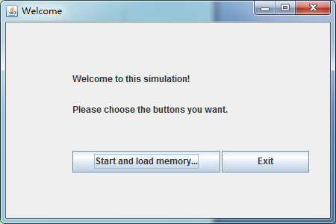

Fig.1 start the simulator

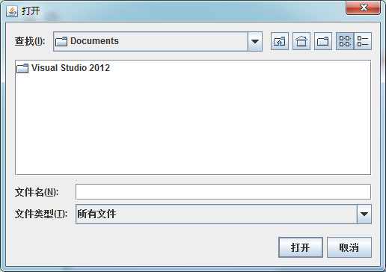

Fig.2 choose file to load for memory

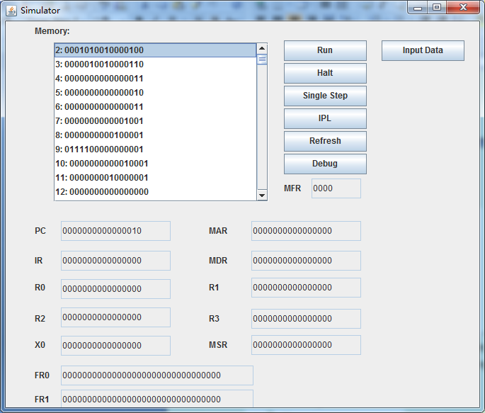

Fig.3 the panel of the simulator

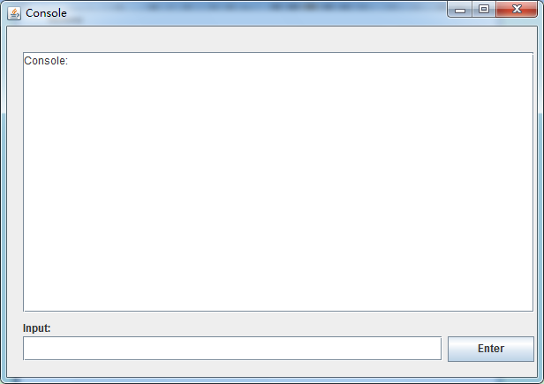

Fig.4 console for debug printing